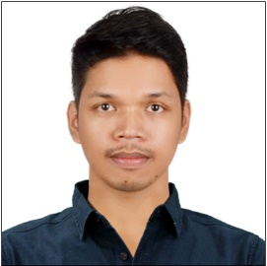**Sherwin Reyes Labrador**

#38 3rd Street St. Michael Village, Orion, Bataan

Contact No.: +63915-113-0899

E-Mail Address: labradorsherwinreyes@gmail.com

**CAREER OBJECTIVES:**

To perform and do things correctly I am expected to do. Learn and nature the value of hard work to asset of the company that would give an opportunity to work for.

**EDUCATIONAL ATTAINMENT:**

College : Bataan Peninsula State University

Balanga City, Bataan

2012 – 2016

**Bachelor of Science in Computer Science**

**(Network and Data)**

Secondary: St. Michael the Archangel Academy

Orion, Bataan

2004 – 2008

Primary : St. Michael the Archangel Academy

Orion, Bataan

1998 – 2004

**PERSONAL INFORMATION:**

Date of Birth : September 11, 1992

Place of Birth : Balanga, Bataan

Civil Status : Single

Religion : Roman Catholic

Citizenship : Filipino

Age : 29 yrs. Old

Height : 5’10’’

Weight : 186 lbs.

**WORK EXPERIENCE:**

Company : GIELENS GARMENTS

Address : Orion, Bataan, PH

Position : ***T-Shirt Printing***

Inclusive Date : April 20, 2017 – December 23, 2021

***Job descriptions:***

* Dealing with customer who starting clothing line, anniversary school shirt, company uniforms and giving them the best offer and quality depending on their budget.
* Color Separating process for client’s layout provided using popular software tools such as photoshop, adobe illustrator etc.
* Production process such as photographic design to silkscreen frame, mixing inks, and give a client’s sample before we do a mass production until we’re up to packaging process.

**KNOWLEDGE, SKILLS, AND ABILITY**

* Proficient with Microsoft Word and Excel and Computer Assembled.
* Skillful with Photoshop, Illustrator, Power Director, Visual Studio, Java, and SQL.
* Self – motivated and passionate in every work that I do.
* Willing to be trained learn new knowledge.
* Ability to communicate goals, Objective, and ideas clearly.
* Ability to work with others as a team to promote and achieve organization goals.
* Flexible in attitude of acceptance to diverse views and opinions.
* Ability to work effectively as a part of a team.

**Sherwin R. Labrador**

Applicant’s Signature’s